Finding Your Place: Embracing Your Role in a Thriving Church Community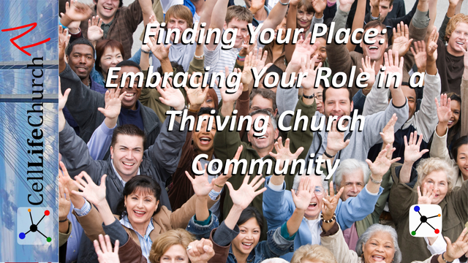

Discover how to grow in your faith and confidently step into your God-given role. Learn how building a strong church community starts with you—serving with others in the love and mission of Jesus Christ.

## Introduction

Every believer has a God-designed role in the Body of Christ. But many Christians struggle to discover how they fit in or what they’re called to do. A strong church community is not built by programs or personalities, it is built by committed people who follow Jesus and serve others. At Cell Life Church, we believe in being the hands and feet of Jesus to communities, regions, nations, and the world. We ask all our cell sites around the world to serve their communities in some tangible way on a regular basis.

In this teaching, we’ll explore how building a strong church community starts with your personal foundation in Christ, using your God-given gifts, and pouring into others as a mentor and encourager.

## Build Your Life on the Firm Foundation of Christ

Jesus is recorded in Matthew 7:24 saying:

### Matthew 7:24

(24)  "Therefore everyone who hears these words of mine and puts them into practice is like a wise man who built his house on the rock.

Jesus' words in Matthew 7 are a vivid call to action. He does not just tell us to listen to His teachings. He calls us to put them into practice. In a world that constantly shifts with culture, emotions, and circumstances, only those who root their lives in God's unchanging truths will stand firm.

When we build on the foundation of Christ, we are not just securing our own faith, we are becoming a source of strength for others in the church. Our testimony becomes a lighthouse, pointing others to Jesus during storms throughout their lives.

Building on Jesus means more than Sunday faith. It means integrating the Word of God into your decisions, reactions, relationships, and lifestyle. Ask yourself these questions:

* Do I go to the Bible first when I need direction or encouragement?
* Am I quick to obey Jesus, or do I delay when it’s inconvenient?

Including the following things will help you to build a firm foundation in Christ.

* Establish a Bible reading rhythm. Start with the Gospels or the book of James.
* Keep a journal of what God is teaching you and how you're applying it. Include prayer requests and record when those prayer requests are answered.
* Ask a trusted friend or mentor to hold you accountable to live what you are learning.

## Discover Your Gifts and Embrace Your Unique Role

Paul gives us a clear illustration of the Church as a body in 1 Corinthians 12:27, which says:

### 1 Corinthians 12:27

(27)  Now you are the body of Christ, and each one of you is a part of it.

Paul’s illustration of the Church as a body is one of the clearest pictures of Christian unity and diversity. Just as a physical body relies on each part to function, the Church thrives when every believer actively contributes. The eye does not try to be the hand, and the ear does not resent not being the foot. Likewise, your value in the Church is not based on how visible or public your role is. It is based on being faithful with what God has entrusted to you.

When people neglect their gifts or believe they have nothing to offer, the whole body suffers. But when every believer steps into their unique role, we begin building a strong church community that glorifies God and blesses people, ultimately pointing people to Jesus.

Embracing your gifts means recognizing that God has wired you in a specific way for a reason. You do not need to do everything, just the thing God has called you to. Your role might evolve over time; the key is to stay faithful and flexible.

Ask yourself these questions:

* What do I enjoy doing that energizes me and helps others?
* Have others affirmed a particular strength or passion in me?
* Am I holding back due to fear, comparison, or past wounds?

Discover your role and embrace your gifts by doing these things:

* Take time this week to pray and reflect on how God has gifted you.
* Talk with a ministry leader at your cell site or church group about areas to serve.
* Try a new area of service or outreach. You may discover hidden strengths.

## Multiply Impact by Mentoring Others

Paul teaches the young pastor Timothy a key concept to grow the Body of Christ in 2 Timothy 2:2, which says:

### 2 Timothy 2:2

(2)  And the things you have heard me say in the presence of many witnesses entrust to reliable people who will also be qualified to teach others.

Paul's words to Timothy show us a model for spiritual multiplication. He was not just concerned about Timothy's growth. Paul wanted Timothy to raise up others who would do the same. This is the biblical pattern for discipleship. Jesus invested deeply in twelve, who then went on to turn the world upside down. There is a fabulous book titled *The Master Plan to Evangelism* by Robert E. Coleman that goes more in depth on this subject and we encourage people to obtain a copy and read it. Simply put, it is all about the Jesus model of evangelism.

Mentoring doesn't mean having all the answers. It means being present, authentic, and intentional. In thriving church communities like Cell Life Church cell sites and church groups, mentoring is how faith becomes generational and sustainable. It is how a movement grows beyond one person or one location.

You can apply this to your life by starting simple. Look for people God has placed in your life; a new believer, a young adult, or a neighbor. Make yourself available to walk with them, pray with them, and encourage them. Sharing what God has taught you could be the very breakthrough someone else needs.

Ask yourself these questions:

* Who am I intentionally investing in right now?
* Am I modeling the kind of faith I want others to imitate?
* Have I invited anyone to walk alongside me in ministry or service?

Multiply your impact and mentor others by doing these simple things:

* Reach out to someone younger in the faith and ask how you can pray for them.
* Invite them into a regular time of devotion and service with you doing things like reading a book of the Bible together, and serving on a project that benefits your community.
* Model consistency, humility, and encouragement in your walk.

## Conclusion

We were never meant to live isolated or passive lives. God designed you to belong, to contribute, and to multiply. Building a strong church community begins with everyday believers like you and me growing in Christ, living out our callings, and helping others do the same.

At Cell Life Church, this is what we are all about. We are not just trying to build a congregation, we are building a movement of Jesus-followers who love radically, serve sacrificially, and mentor intentionally.

Your next steps are straightforward and we encourage you to do these things.

1. Strengthen your foundation through daily Scripture reading, prayer, and obedience.
2. Discover and actively use your spiritual gifts in your cell site, church group, and your community.
3. Mentor someone else in their walk with Jesus and invite them to do the same.

Let’s not just attend church, let’s be the Church. Let’s be the hands and feet of Jesus, building something that lasts for eternity. If you’re not yet part of a Cell Life Church cell site or group, visit [www.CellLifeChurch.org](https://www.CellLifeChurch.org) to find one near you or start one with our help.

We leave you with one final scripture verse from the Apostle Paul to the Ephesians which is just as applicable today as it was 2000 years ago. Ephesians 4:16 says:

### Ephesians 4:16

(16)  From him the whole body, joined and held together by every supporting ligament, grows and builds itself up in love, as each part does its work.