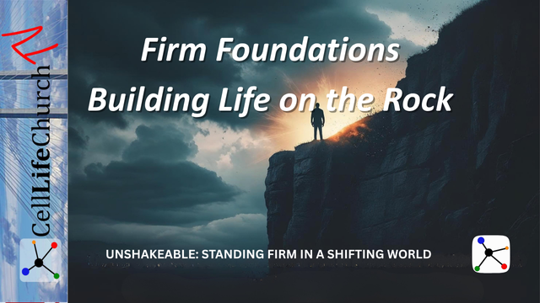
Firm Foundations – Building Life on the Rock
Discover how to build your life on the unshakeable foundation of Jesus and stand firm when life’s storms hit.

Introduction
Welcome to Unshakeable: Standing Firm in a Shifting World, a brand-new teaching series from Cell Life Church TV. In this series, we are exploring how to remain steady in our faith when the world around us is filled with uncertainty and instability.
Each episode will equip you with biblical truth to stand firm when life gets shaky, because faith built on Christ does not collapse when the winds blow or the storm rages.
Today, we begin with the most important truth of all: what you build your life on matters. Your foundation determines your ability to endure hardship, pressure, and uncertainty.
Let’s read Jesus’ words in Matthew 7:24-26:

Matthew 7:24-26
(24) "Therefore everyone who hears these words of mine and puts them into practice is like a wise man who built his house on the rock. (25) The rain came down, the streams rose, and the winds blew and beat against that house; yet it did not fall, because it had its foundation on the rock. (26) But everyone who hears these words of mine and does not put them into practice is like a foolish man who built his house on sand.

Storms Don’t Create Weakness—They Reveal It
Jesus didn’t say “if” storms come, He said “when”. Storms are part of life. They may come as financial loss, health crises, broken relationships, moral confusion in society, spiritual doubts, or persecution.
When these storms come, they don’t suddenly create weakness; they reveal whether your foundation is strong or shaky. The one who stands is not the one who avoids trouble, but the one who has built wisely beforehand.
The effect storms have on our lives reveals what kind of foundation we have built on. This helps us evaluate our lives and determine whether we have built them on a firm foundation or shifting sand.
Reflect on the last storm you went through. Ask yourself honestly, “What did it reveal about my foundation?” Spend time in prayer, asking God to expose any weak areas and give you the courage to rebuild. Write down what God reveals to you in your journal and use that as a reminder to pray and also as an encouragement to build your life on the only unshakeable foundation, Jesus.
So if storms reveal the strength of our foundation, what exactly should we be building our lives on? That leads us to our next truth: Christ is the only unshakeable foundation.

Christ Is the Only Unshakeable Foundation
In a culture full of shifting values and changing definitions of truth, people are building their lives on sand. This foundation is made of personal preference, public opinion, and even religion without relationship.
But the Bible tells us over and over that Jesus is the only true Rock.
“For no one can lay any foundation other than the one already laid, which is Jesus Christ.”
Let’s look at two passages of scripture, one in the New Testament from the Apostle Paul and one in the Old Testament from King David.
Paul teaches us in 1 Corinthians 3:11

1 Corinthians 3:11
(11) For no one can lay any foundation other than the one already laid, which is Jesus Christ.
King David teaches us in Psalm 62:2

Psalms 62:2
(2) Truly he is my rock and my salvation; he is my fortress, I will never be shaken.
Standing firm in faith begins by surrendering your life fully to Christ, not just believing He exists, but submitting your life to Him as Savior and Lord. Remember, even the devil believes in Jesus; he just refuses to surrender to him.
Declare it today, “Jesus, You are the foundation of my life.” If there are areas you have built on human wisdom, self-effort, or cultural values, confess that to the Lord and reestablish Him as your center. Write the areas the Lord reveals to you in your journal so you can reflect on these as you continue to pray and build a firm foundation that is unshakeable by the storms of this world.
So, if we are supposed to build our lives on the firm foundation of Jesus, how do we do that? Is it just believing in Jesus, or is there something else?

A Firm Foundation Is Built by Obedience, Not Just Belief
Both people in Jesus’ parable heard His words, but only one acted on them. The difference between the house that stood and the one that fell was not knowledge; it was obedience.
We read in James 1:22

James 1:22
(22) Do not merely listen to the word, and so deceive yourselves. Do what it says.
It is easy to assume that knowing more Scripture makes us stronger Christians. But Jesus is not just after what we know; He is after how we live. Obedience is the true test of maturity, not information. It is possible to attend church, read Scripture, and enjoy Christian media, but still live disconnected from the power of obedience. Faith becomes firm through practice. These are not natural reactions to the storms; they are supernatural. These reactions require our foundation to be built on the Rock, Jesus.
Some of these reactions are:
- Forgiving someone when you would rather hold a grudge.
- Tithing when finances are tight.
- Choosing truth over convenience.
- Loving your enemy.
- Choosing to wait on God instead of forcing your own way.
Each small act of obedience is like driving another anchor into the Rock and establishing a firm and unshakeable foundation.
Choose one specific area of your life where you have delayed or avoided obedience to Jesus. Take one intentional step this week to act on what Jesus has already told you to do. Obedience is where the foundation is poured. Take time to write this in your journal and reflect on it.

Conclusion
The time to start building your firm foundation is now. The beautiful truth of this parable is that it is not too late. If you realize you have been building on sand—emotion, opinion, fear, or tradition—God invites you to begin building on the Rock today.
Jesus does not promise an easy life, but He promises you will not collapse when the pressure comes, if you have built on Him.
You can be unshakeable, not because you are strong, but because your life is grounded in Someone who never moves.

Challenge for This Week
Your challenge for this week is to:
- Read Matthew 5–7 (the Sermon on the Mount) and reflect on how you can put Jesus’ words into action.
- Ask, “Where in my life am I standing on sand instead of the Rock?”
- Pray daily, “Lord, help me build every area of my life on Your truth and not my own.”

Next Week
Be sure to join us for the next teaching of Unshakeable: Standing Firm in a Shifting World, “Unmoved by Culture – Living with a Biblical Worldview.” We will talk about how to stand for truth when everything around us pushes us to compromise.

