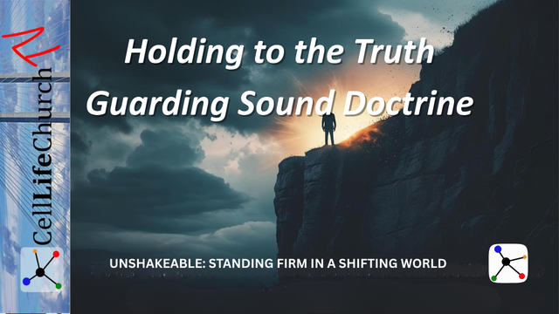
Holding to the Truth – Guarding Sound Doctrine
In a world full of confusion and compromise, discover how guarding sound doctrine helps you stand firm in faith and remain anchored in truth.

Introduction
Welcome back to our teaching series, Unshakeable: Standing Firm in a Shifting World, here on Cell Life Church TV. In this series, we are learning how to remain rooted in Jesus Christ and strong in our faith, even when the world around us feels uncertain, unstable, and often opposed to biblical truth.
In Part 1, Firm Foundations – Building Life on the Rock, we learned that the storms of life reveal whether our lives are built on shifting sand or on the unshakeable foundation of Jesus Christ. Last week in Part 2, Unmoved by Culture – Living with a Biblical Worldview, we talked about how our thinking must be shaped by the Word of God, not by popular opinion, and how living with a biblical worldview enables us to see clearly and live boldly in today’s culture.
Today, we build on that foundation and framework by focusing on the importance of truth. In a time when many are drifting away from sound teaching, believers must guard sound doctrine and hold tightly to what is true. Only then can we stand firm in faith and avoid being carried away by error or deception.
Let us explore what it means to hold to the truth and why guarding sound doctrine matters more than ever.

Truth Is Not Flexible—It Is Foundational
We live in a culture that often treats truth as relative, something you can shape to fit your desires or preferences. But the Bible teaches that truth is not flexible. It is eternal, objective, and rooted in the very nature of God.
Jesus prays in John 17:17

John 17:17
(17) Sanctify them by the truth; your word is truth.
Jesus did not say that His Word contains truth. He said His Word is truth. That means we cannot redefine it, edit it, or ignore the parts we do not like. When we treat God’s Word as optional, we begin to build our faith on opinion rather than revelation.
The Apostle Paul warned that a time would come when people would reject sound doctrine. Paul writes to Timothy in 2 Timothy 4:3

2 Timothy 4:3
(3) For the time will come when people will not put up with sound doctrine. Instead, to suit their own desires, they will gather around them a great number of teachers to say what their itching ears want to hear.
We are living in those times now. People want affirmation more than truth, and comfort more than conviction. But truth is not meant to cater to our desires. It is meant to form our hearts and guide our lives.
Ask yourself, “Are there parts of the Bible I avoid because they make me uncomfortable?” This week, read one of those passages with an open heart. Ask the Holy Spirit to show you what God wants to teach you through it. Write your reflections in your journal.

Sound Doctrine Keeps Us Anchored in Faith
Sound doctrine is more than theological correctness; it is the framework that keeps us anchored when we are tempted to drift.
We read in Ephesians 4:14

Ephesians 4:14
(14) Then we will no longer be infants, tossed back and forth by the waves, and blown here and there by every wind of teaching and by the cunning and craftiness of people in their deceitful scheming.
Without sound doctrine, believers are vulnerable to confusion, deception, and even spiritual shipwreck. That is why the early church placed such a high priority on devoting themselves to the apostles’ teaching, as it says in Acts 2:42. Truth was not just taught, it was lived, guarded, and passed on faithfully.
To stand firm in faith, we must know what we believe and why we believe it. This requires us to spend time in the Word, be part of a community that values truth, and test everything we hear against Scripture.
Sound doctrine also protects the unity and purity of the Church. When we remain grounded in the truth of Scripture, we will not be divided by fads, trends, or human agendas.
Take time this week to write down the core beliefs of your faith. Can you explain what you believe about God, salvation, grace, sin, and eternity? If you are unsure, begin studying the foundational doctrines of the Christian faith. You can read the eight fundamental doctrinal beliefs of Cell Life Church on our website. Let this strengthen your understanding and your confidence in the truth.

Holding to the Truth Requires Courage and Discernment
Holding to the truth is not always popular. In today’s world, truth is often seen as intolerant, outdated, or unkind. But the Bible calls us to speak the truth in love and to stand firm when truth is under attack.
Paul writes to the church in Corinth in 1 Corinthians 16:13

1 Corinthians 16:13
(13) Be on your guard; stand firm in the faith; be courageous; be strong.
To guard sound doctrine, we must be willing to resist compromise, even when it costs us approval, comfort, or convenience. This requires discernment. We must recognize false teaching and have courage, choosing to reject it when we see it.
Discernment comes through constant use of God’s Word. We read in Hebrews 5:14

Hebrews 5:14
(14) But solid food is for the mature, who by constant use have trained themselves to distinguish good from evil.
You do not need to be a Bible School graduate to recognize false doctrine. You need to be a student of God’s Word. The more familiar you are with truth, the quicker you will recognize what is false.
Think of a time when you heard or read a message that sounded spiritual, but something felt “off.” Go back to God’s Word and examine it. Ask the Holy Spirit for discernment. Begin a habit of testing everything by Scripture, and encourage others in your cell site or group to do the same.

Conclusion
Truth is under pressure in today’s world, but it is not fragile. It does not need to be improved, updated, or softened. It needs to be believed, obeyed, and guarded.
To stand firm in faith, we must hold to the truth with humility, conviction, and love. We must build our lives on sound doctrine so that we will not be tossed around by the opinions of the day or the shifting winds of culture.
When you build your life on the truth of God’s Word, you will remain unshakeable, no matter what comes your way.

Challenge for This Week
- Read 2 Timothy 4:1–5 and Ephesians 4:11–16.
- Ask, “Am I being shaped more by popular voices or by sound doctrine?”
- Pray, “Lord, help me love the truth, stand firm in faith, and guard what You have entrusted to me.”

Next Week
In Part 4 of Unshakeable: Standing Firm in a Shifting World, we will look at what it means to stay faithful under pressure. Do not miss Courage in the Fire – Faith Under Pressure, where we will learn from examples like Shadrach, Meshach, and Abednego, and discover how to stand strong when our faith is tested by trials.

