Courage in the Fire – Faith Under Pressure
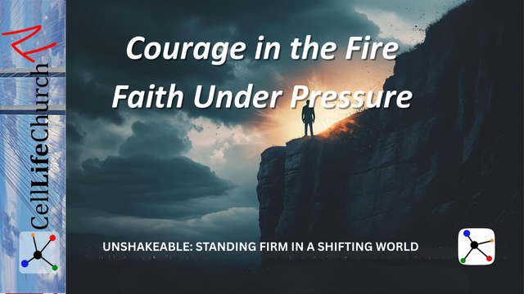
Discover how to stand firm in faith with courage when your beliefs are tested, your convictions are challenged, and your obedience costs you something.

Introduction
Welcome back to Unshakeable: Standing Firm in a Shifting World, our teaching series here on Cell Life Church TV. We are walking through how to remain anchored in our faith in Jesus Christ, even when the world around us is unstable, confusing, or outright hostile to biblical truth.
In Part 1, Firm Foundations – Building Life on the Rock, we learned that our ability to stand in the storm depends on the foundation we build on—Jesus Christ. In Part 2, Unmoved by Culture – Living with a Biblical Worldview, we saw how our thinking must be shaped by the Word of God, not by the shifting opinions of society. Last week, in Part 3, Holding to the Truth – Guarding Sound Doctrine, we looked at the importance of building our lives on biblical truth and resisting false teachings.
Today, we move from the foundations of faith to the fires of testing. What happens when your commitment to Jesus is not just unpopular, but costly? What does it look like to stand firm in faith when obedience brings pressure, persecution, or personal loss?
Let us learn how to walk with faith under pressure, and discover that true courage is not found in strength; it is found in surrender to God.

Faith Is Proven in the Fire
It is easy to talk about faith when life is comfortable. But faith under pressure reveals what we truly believe. The story of Shadrach, Meshach, and Abednego in Daniel 3 is a powerful example of what it means to have unshakeable faith when obedience to God is tested.
King Nebuchadnezzar commanded everyone to bow down to a golden statue. The punishment for disobedience was death by being thrown into a blazing furnace. These three men refused to bow.
We read in Daniel 3:16-18

Daniel 3:16-18
(16) Shadrach, Meshach and Abednego replied to him, "King Nebuchadnezzar, we do not need to defend ourselves before you in this matter. (17) If we are thrown into the blazing furnace, the God we serve is able to deliver us from it, and he will deliver us from Your Majesty's hand. (18) But even if he does not, we want you to know, Your Majesty, that we will not serve your gods or worship the image of gold you have set up."
Their response is powerful: “Even if he does not.” That is what standing firm in faith looks like. They did not worship God only if He would rescue them. They worshiped Him because He is worthy, no matter the outcome.
Today, you may not face a fiery furnace, but you may face pressure at work, rejection from friends, or criticism for standing on biblical truth. How you respond under pressure reveals whether your faith is built on convenience or conviction.
Reflect on a time when obedience to God was difficult. What did it reveal about your trust in Him? Ask the Lord to prepare your heart now for future trials. Write a personal declaration: “Even if He does not, I will still trust Him.”

God Does Not Always Deliver Us From the Fire—But He Always Joins Us In It
When Shadrach, Meshach, and Abednego were thrown into the furnace, something incredible happened:
We read in Daniel 3:24-25

Daniel 3:24-25
(24) Then King Nebuchadnezzar leaped to his feet in amazement and asked his advisers, "Weren't there three men that we tied up and threw into the fire?" They replied, "Certainly, Your Majesty." (25) He said, "Look! I see four men walking around in the fire, unbound and unharmed, and the fourth looks like a son of the gods."
God did not prevent them from being thrown in. He met them in the fire.
Sometimes, we want God to remove us from pressure. But often, He reveals His presence through it. When we walk through fire with Him, our faith is refined, our testimony is strengthened, and His glory is revealed.
The prophet Isaiah tells us in Isaiah 43:2-3

Isaiah 43:2-3
(2) When you pass through the waters, I will be with you; and when you pass through the rivers, they will not sweep over you. When you walk through the fire, you will not be burned; the flames will not set you ablaze. (3) For I am the LORD your God, the Holy One of Israel, your Savior; I give Egypt for your ransom, Cush and Seba in your stead.
Standing firm in faith does not mean escaping hardship. It means choosing to trust God, knowing that He walks with us in the heat.
If you are walking through a trial right now, ask the Lord to help you recognize His presence with you. Write down how He has shown up in past seasons of pressure. Let that testimony strengthen you today.

Faith Under Pressure Leaves a Lasting Impact
Shadrach, Meshach, and Abednego did not just survive the fire; they influenced a nation. After seeing their courage and God’s faithfulness, even King Nebuchadnezzar responded:
We read his response in Daniel 3:28-29, which says:

Daniel 3:28-29
(28) Then Nebuchadnezzar said, "Praise be to the God of Shadrach, Meshach and Abednego, who has sent his angel and rescued his servants! They trusted in him and defied the king's command and were willing to give up their lives rather than serve or worship any god except their own God. (29) Therefore I decree that the people of any nation or language who say anything against the God of Shadrach, Meshach and Abednego be cut into pieces and their houses be turned into piles of rubble, for no other god can save in this way."
Faith under pressure is not just about your personal endurance; it becomes a testimony to others. Your courage in the fire might be the very thing God uses to show His power to those watching your life.
When you remain faithful under pressure:
- Your children notice.
- Your coworkers see integrity.
- Your community sees hope.
- The enemy is silenced.
- And God is glorified.
Do not waste the fire. Let it purify you, and let it point others to Christ.
Think of someone in your life who is watching how you handle hardship. What story are you telling them with your faith? Ask God to use your trial for His glory, and look for opportunities to encourage others through your testimony.

Conclusion
The fire will come. The pressure will rise. But you do not face it alone. The same God who stood with Shadrach, Meshach, and Abednego stands with you.
You can have faith under pressure. You can live with courage in the fire. Not because you are strong, but because God is present, faithful, and unchanging.
To stand firm in faith is not to escape every trial. It is to endure them with unwavering trust in the One who never leaves your side.

Challenge for This Week
- Read Daniel 3 and Isaiah 43:1–3.
- Ask, “Am I trusting God only when it is easy, or even when it costs me something?”
- Pray, “Lord, give me courage in the fire. Help me to stand firm in faith, and let my testimony bring You glory.”

Next Week
Join us next time for Part 5 of Unshakeable: Standing Firm in a Shifting World, where we will focus on Anchored in Hope – Enduring Through Uncertainty. We will explore how hope in Jesus keeps us steady, even when the future feels uncertain or delayed.

