Anchored in Hope – Enduring Through Uncertainty
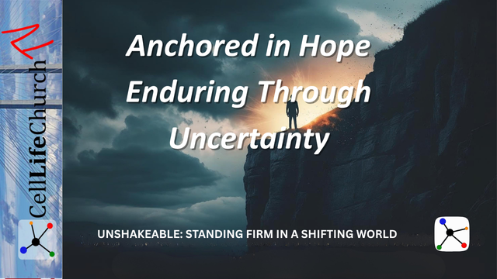
Discover how to stand firm in faith by placing your hope in Christ, not in circumstances, timing, or outcomes.

Introduction
Welcome back to Unshakeable: Standing Firm in a Shifting World, our teaching series here on Cell Life Church TV. We are learning how to stay grounded in Jesus and hold fast to our faith when life is confusing, culture is shifting, and trials are ongoing.
In Part 1, we talked about building our lives on the firm foundation of Jesus. In Part 2, we explored how to live with a biblical worldview, resisting the pressures of culture. In Part 3, we learned the importance of guarding sound doctrine. And last week, in Part 4, we were reminded that faith under pressure requires courage, especially when our obedience costs us something.
Today, we turn our attention to hope, not the shallow kind of hope that wishes things were better, but the deep, unshakeable hope in Christ that anchors us when everything feels uncertain.
Let us learn what it means to be anchored in hope, and how hope enables us to endure when life does not go as planned.

Hope in Christ Is Not Based on Circumstances
When people talk about hope today, they often mean wishful thinking; something they would like to happen, but cannot be sure of.
Biblical hope is different. It is not based on circumstances or feelings. It is not rooted in whether things go our way or improve quickly. Biblical hope is confidence in God’s promises, grounded in His unchanging nature.
We read in the first part of Hebrews 6:19

Hebrews 6:19a
(19) We have this hope as an anchor for the soul, firm and secure…
The writer of Hebrews is describing a hope that is steady in storms. It is an anchor that keeps us from drifting when life gets hard.
Your circumstances may change. The future may feel uncertain. But the hope in Christ is not shaken by delay, disappointment, or hardship.
We read in Psalms 42:5

Psalms 42:5
(5) Why, my soul, are you downcast? Why so disturbed within me? Put your hope in God, for I will yet praise him, my Savior and my God.
This kind of hope declares, “I will praise Him, even before I see the breakthrough.”
Think about an area of your life where you are feeling discouraged or uncertain. Write down one promise of God that applies to that situation. Meditate on it this week and remind yourself daily that your hope is in Christ, not in your current situation.

Waiting With Hope Is Part of Standing Firm in Faith
One of the hardest parts of following Jesus is waiting, especially when you are praying for healing, direction, provision, or resolution. In the waiting, it is tempting to lose heart or take matters into your own hands.
But hope teaches us to wait well. Romans 8:25 tells us:

Romans 8:25
(25) But if we hope for what we do not yet have, we wait for it patiently.
To stand firm in faith means trusting that God is working, even when you cannot see the evidence yet. Waiting is not wasted when your heart is anchored in Him.
The prophet Isaiah reminds us that strength is renewed through waiting in Isaiah 40:31, which says:

Isaiah 40:31
(31) but those who hope in the LORD will renew their strength. They will soar on wings like eagles; they will run and not grow weary, they will walk and not be faint.
The world says, “Act now. Fix it yourself.” But the Lord says, “Wait on Me. I am faithful.”
Where in your life are you tempted to give up or give in during the wait? Choose one area to surrender back to God. Pray daily this week, “Lord, help me wait with hope. Strengthen me as I trust in You.”

Hope Points Us Beyond This Life
As believers, our hope is not just for today, it is for eternity. This world is not our final home. Our ultimate hope is that Jesus will return, justice will be done, and every tear will be wiped away.
Peter encourages us in 1 Peter 1:3 with:

1 Peter 1:3
(3) Praise be to the God and Father of our Lord Jesus Christ! In his great mercy he has given us new birth into a living hope through the resurrection of Jesus Christ from the dead,
We do not live as people in despair. We live as people of living hope.
This is why we can endure hardship, disappointment, and uncertainty. Our hope in Christ is not limited to this life. It looks forward to resurrection, restoration, and eternal joy.
Paul wrote these words from prison in 2 Corinthians 4:17, saying:

2 Corinthians 4:17
(17) For our light and momentary troubles are achieving for us an eternal glory that far outweighs them all.
You can stand firm in faith when you remember that what you see is not all there is. Your story is not finished. Your eternity is secure.
Ask yourself, “Am I living with eternity in mind?” Spend time this week thinking about the hope of heaven. Let it reframe how you see your challenges, and let it stir up joy even in the middle of trials.

Conclusion
Hope is an anchor and what holds us steady when life gets messy. It does not remove the waves, but it keeps us from being swept away.
To be unshakeable and stand firm in faith, you must be anchored in hope, not in quick fixes, perfect timing, or predictable outcomes, but in the character and promises of Jesus Christ.
When everything around you is uncertain, your hope in Christ can remain secure.

Challenge for This Week
Your challenge for this week is to:
- Read: Hebrews 6:17–19, Psalm 42, and 1 Peter 1:3–9.
- Ask: “Where have I allowed discouragement or delay to rob me of hope?”
- Pray: “Lord, help me place my hope in You. Anchor me in Your promises so that I may endure with strength and joy.”

Next Week
Join us for the final teaching in Unshakeable: Standing Firm in a Shifting World, titled Standing Together – The Strength of Christian Community. We will discover how believers strengthen one another and why standing firm in faith is not meant to be done alone.

