Standing Together – The Strength of Christian Community
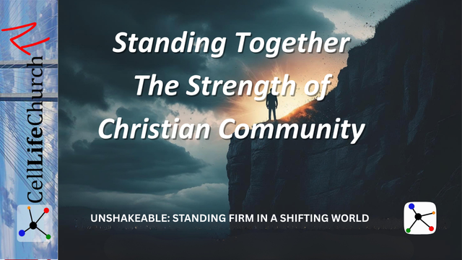
Learn why standing firm in faith is never meant to be done alone and how Christian community equips us to remain unshakeable in a shifting world.

Introduction
Welcome back to Unshakeable: Standing Firm in a Shifting World on Cell Life Church TV. Over the last five weeks, we have learned how to build our lives on the unshakeable foundation of Jesus Christ, resist cultural pressures with a biblical worldview, guard sound doctrine, remain courageous when our faith is tested, and endure uncertainty with hope in Christ.
Now, in this final teaching, we will look at how God strengthens us through Christian community. Standing firm in faith is not something we are called to do in isolation. God designed us to live in relationship with other believers because together, we are stronger, more encouraged, and more effective in showing the world who Jesus is.

We Were Created for Community
From the beginning, God declared that it was not good for man to be alone; we read that in Genesis 2:18. He created us for a relationship with Him and with others. This truth applies to every believer today: we were not created to stand alone.
Isolation makes us vulnerable. When we try to follow Christ by ourselves, we become easy targets for discouragement, temptation, and spiritual apathy. The enemy loves to isolate believers because he knows that a disconnected Christian is often a struggling Christian.
The Bible reminds us in Ecclesiastes 4:9–12:

Ecclesiastes 4:9-12
(9) Two are better than one, because they have a good return for their labor: (10) If either of them falls down, one can help the other up. But pity anyone who falls and has no one to help them up. (11) Also, if two lie down together, they will keep warm. But how can one keep warm alone? (12) Though one may be overpowered, two can defend themselves. A cord of three strands is not quickly broken.
Christian community provides us with the care, encouragement, and accountability we need to keep going. It is where we can be vulnerable, find prayer support, and experience the tangible love of Christ.
If you find yourself walking alone in your faith, it is time to take a step toward Christian community. Join a small group or cell site, serve alongside others in a ministry, or invite a fellow believer to pray with you regularly. Do not let pride or busyness rob you of this gift.

Christian Community Strengthens Us When Faith Is Tested
Faith is often tested through trials, pressure, and seasons of waiting. During these times, Christian community becomes a lifeline. We need others to help us remain standing firm in faith when we feel weak.
The believers in the book of Hebrews were under intense persecution. The writer urged them in Hebrews 10:24–25:

Hebrews 10:24-25
(24) And let us consider how we may spur one another on toward love and good deeds, (25) not giving up meeting together, as some are in the habit of doing, but encouraging one another—and all the more as you see the Day approaching.
When we meet together, we are reminded that we are not alone. We can share our struggles, lift one another up in prayer, and offer a godly perspective when someone’s vision is clouded by fear or discouragement.
Think about Moses in Exodus 17. When the Israelites were fighting the Amalekites, Moses’ arms grew tired as he held the staff of God. Aaron and Hur came alongside him and held up his arms until victory was secured. This is a picture of Christian community in action: when your arms get heavy, someone else can hold them up for you.
Look for someone whose “arms are tired” right now. Maybe it is a friend at church, a coworker who is a believer, or someone in your family. Offer to encourage them, pray with them, or simply be present. Remember, Christian community is about both giving and receiving support.

Community Displays the Love of Christ to the World
Christian community is not only for our benefit. It is one of the most powerful witnesses to the world. Jesus is recorded saying in John 13:34-35:

John 13:34-35
(34) "A new command I give you: Love one another. As I have loved you, so you must love one another. (35) By this everyone will know that you are my disciples, if you love one another."
When believers live in unity, bear one another’s burdens, and forgive as Christ forgives us, the world notices. In a culture marked by division and loneliness, authentic Christian community stands out as a place of belonging, hope, and unconditional love.
The Apostle Paul wrote in Galatians 6:2:

Galatians 6:2
(2) Carry each other's burdens, and in this way you will fulfill the law of Christ.
When we live this way, we show the world a glimpse of God’s kingdom. People who feel alone and lost are drawn to Jesus because they see His love expressed through His people.
Ask yourself, “Does my life reflect the love of Christ to others in my community?” Choose one practical way this week to serve someone in your church, cell site, or small group sacrificially, without expecting anything in return. Your act of love may be the encouragement someone desperately needs.

Conclusion
God never intended for us to stand firm in faith on our own. He designed us to be part of a family, a Christian community, where we can be strengthened, encouraged, and reminded of truth.
This entire series has been about living unshakeable lives in a world that is constantly shifting. The foundation is Jesus Christ. The framework is a biblical worldview and sound doctrine. The courage to persevere comes from trusting God in trials. The endurance comes from hope in Christ. And the strength to keep going is multiplied when we stand together.

Challenge for This Week
- Read: Ecclesiastes 4:9–12, Hebrews 10:24–25, and Galatians 6:2.
- Ask: “Am I walking in authentic Christian community, or am I trying to stand alone?”
- Pray: “Lord, help me build deeper relationships with other believers and stand firm together in faith.”

Series Wrap-Up
Thank you for joining us for Unshakeable: Standing Firm in a Shifting World. Our prayer is that you now feel equipped to live out your faith with confidence, clarity, hope, and perseverance.
Remember: the world will continue to shift, but we learn in Hebrews 13:8 that Jesus Christ is the same yesterday, today, and forever. Stay rooted in Him. Stand firm in faith. And stand together as the body of Christ.

