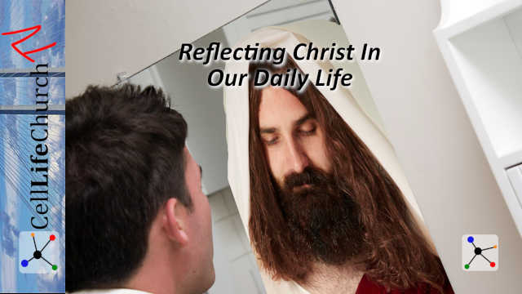Reflecting Christ In Our Daily Life

What do you see when you look in a mirror? What do others see when they look at you? Today we are talking about reflecting Christ in our daily life.

## Introduction

When we look into a mirror, we know what to expect to see. We see the reflection of our own face. When we look on social media at pictures of ourselves we see the activities we participate in and the places we go along with the people we spend time with. This is a reflection of our life.

Others see us too. They see who we are and how we act. People around us see how we respond to different situations. If we are facing a troubling time, people will see how we respond to it and if we receive praise for something, people will likewise see how we receive that. This is a reflection on us and what we stand for and believe. We should be reflecting Christ in our daily life.

An almost daily prayer of mine is that Jesus would shine through me. I ask him to lead me so that people do not see me, they see him in me. I want to reflect Christ in my daily life.

## Reflecting Ourselves In Stead of Christ Daily

Since the beginning in the Garden of Eden when Adam and Eve disobeyed God and brought sin into the world mankind has been self-focused. We are inherently selfish. That is what sin is. It is rooted in selfishness. We think of ourselves first. Our own wants and desires often come before others. This is the natural state of mankind.

You can see what we mean by this with a quick trip to any social media site. You will see pictures of people indulging themselves with little or no regard for anyone else. You see how the world without God responds to life.

The world tries to explain things through philosophy and man’s wisdom. Look at what Colossians 2:8 says:

### Colossians 2:8

(8) See to it that no one takes you captive through hollow and deceptive philosophy, which depends on human tradition and the elemental spiritual forces of this world rather than on Christ.

Paul gives sound advice here and points out that the world tries to explain and solve things through deception and man’s wisdom. Man’s wisdom is flawed at its best.

Proverbs 3:5-7 says:

### Proverbs 3:5-7

(5)  Trust in the LORD with all your heart and lean not on your own understanding;  (6)  in all your ways submit to him, and he will make your paths straight.  (7)  Do not be wise in your own eyes; fear the LORD and shun evil.

Our perspective is skewed and we cannot completely trust our own understanding. To reflect Christ in our daily life we must stay connected with God and do what he asks of us, even when it does not make sense in our own understanding. To quote Jesus, “Not my will, but yours be done.”

Jesus has asked us all to be witnesses to this world of his love, grace, mercy, and forgiveness. Is your life reflecting that? In other words, is your life reflecting Christ daily?

## Reflecting Christ Instead of Ourselves Daily

A witness is someone who shares what they have personally seen, heard, or experienced. Nothing more and nothing less. Jesus is recorded in Acts 1:8 saying:

### Acts 1:8

(8) But you will receive power when the Holy Spirit comes on you; and you will be my witnesses in Jerusalem, and in all Judea and Samaria, and to the ends of the earth."

It is important to understand that we cannot be witnesses of Jesus Christ without the power and equipping of the Holy Spirit. When we are truly a witness for Christ we reflect him and his love, grace, mercy, and forgiveness for others.

Paul tells us what that looks like in his letter to Titus on the island of Crete. Titus 2:7-8 says:

### Titus 2:7-8

(7) In everything set them an example by doing what is good. In your teaching show integrity, seriousness (8) and soundness of speech that cannot be condemned, so that those who oppose you may be ashamed because they have nothing bad to say about us.

Titus was led to Jesus by Paul and Paul put him in leadership over the church in Crete. Paul is giving Titus instructions on how people should behave within their homes and workplaces. Part of Paul’s instructions are for Titus himself and that is verses 7 and 8.

These are great instructions for us all to follow. We all are to be making disciples and therefore are leading others and being an example to them. That makes this verse applicable to us all, not just church leaders.

### Do What Is Good

The first part Paul says is to do what is good in everything we do. Whatever you are doing regardless of who is around we should do good. We should have an attitude of putting others first before ourselves. This may be something as simple as holding a door open for someone or as big as helping a stranger who has a broken-down car on the side of the road.

We are faced with situations every day that will allow us to do good and reflect Christ, or to be selfish and reflect ourselves.

### Show Integrity

I learned a long time ago that your integrity cannot be taken from you. You can only give it away. Integrity has often been defined as doing what is right even when no one else is around to see it. When reflecting Christ daily we must speak and share with integrity, using words that cannot be twisted. We do not need to embellish or exaggerate the truth to make it more sensational so people will want to listen.

Share what the Lord prompts you to, the way he prompts you to and you will reflect Christ. Using the words the Lord gives us will make it so the world cannot twist what we say. The world will find the exaggeration and see it for what it is and that will take the focus away from what Jesus is trying to say or do through us.

### What Would Jesus Do

In short, we must be continually asking ourselves, what would Jesus do in this situation? How would Jesus respond to this question? What would Jesus say to this individual?

When we are in constant communication with Jesus and we invite him into every part of our life we will know how to answer those questions every time. In those instances, we will reflect Christ.

## Spend Time in the Bible

It has been said, “Show me your friends and I will show you your future.” This is a very true statement. The more time we spend with someone or a group of people, the more we become like them. Husbands and wives are a great example of this. The longer you are married the easier it is to know what the other is thinking and you can often complete each other’s sentences.

We must spend time reading the Bible frequently if we are going to be like Jesus and reflect Christ in our daily lives. We must know and understand the scriptures so we can help others be more like Christ. Constant prayer and reading are just as essential to our spiritual life as food and water are to our physical life.

Jesus is recorded in John 6:36 saying:

### John 6:35

(35)  Then Jesus declared, "I am the bread of life. Whoever comes to me will never go hungry, and whoever believes in me will never be thirsty.

Jesus is our source of everything we need. He is the living word of God. He sent the Holy Spirit to equip us and guide us as we show the love, grace, mercy, and forgiveness of Jesus Christ to everyone we come in contact with.

## Conclusion

It is each of our responsibilities to be an example of Christ in everything we do. We should always teach and lead with integrity and truth so that it cannot be condemned by the world.

As Christians, we should reflect Christ when we look in the mirror. We should see service to others and being servants to others when we see photos of ourselves. In short, we should reflect Christ in our daily lives more than we reflect ourselves.