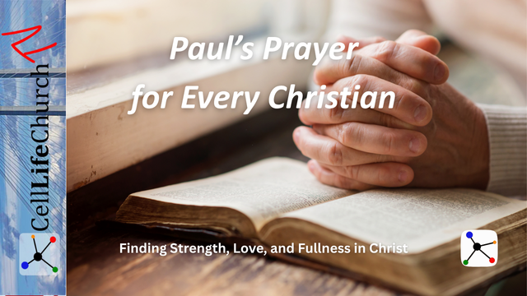
Paul’s Prayer for Every Christian
  - Finding Strength, Love, and Fullness in Christ
The Apostle Paul’s prayer in Ephesians 3 is one of the most powerful passages in all of Scripture. It reveals God’s deep desire that every believer be strengthened by the Holy Spirit, rooted in His unshakable love, and filled with His divine fullness. Discover how this prayer still speaks life, courage, and purpose to every follower of Jesus today.

Introduction
When the Apostle Paul wrote to the Ephesian church, he was writing to a community learning to live out their faith in a world that often opposed it. His prayer was not just for them but for every believer who would follow, believers like you and me.
Paul’s words in Ephesians 3:16–19 are more than a poetic blessing; they are a roadmap for Christian growth and maturity. In this prayer, we find three timeless desires of God for His people: to be strengthened by the Holy Spirit, to be rooted and established in Christ’s love, and to be filled with all the fullness of God.
Let’s explore each part of this prayer and see how it applies to our lives today.

Strengthened with Power Through the Holy Spirit
We read how Paul begins by praying in Ephesians 3:16-17,

Ephesians 3:16-17a
(16) I pray that out of his glorious riches he may strengthen you with power through his Spirit in your inner being, (17) so that Christ may dwell in your hearts through faith.
Paul understood that the Christian life cannot be lived by human strength alone. The trials of life, the temptations of the world, and the spiritual battles we face all require a strength beyond ourselves. That strength comes from the Holy Spirit working within us.
Notice that Paul prays that we would be strengthened out of God’s glorious riches. Some translations say according to His glorious riches. This means God’s power is not given in small portions; it flows from His infinite supply.
When Christ dwells in your heart, His Spirit brings peace where there was fear, hope where there was despair, and courage where there was weakness. This strength is not about self-reliance; it is about divine dependence.
When you feel overwhelmed, stop and ask the Lord to strengthen your inner being through the Holy Spirit. Spend time daily in prayer, allowing His presence to refill you with spiritual endurance. Power to live for Christ comes not from willpower, but from the indwelling Christ who renews you from within.
Where do you need the Holy Spirit’s strength most in your life right now? How has God’s power helped you overcome a challenge that seemed impossible? Share your answers in the comments below.

Rooted and Established in the Love of Christ
Paul continues in Ephesians 17-18,

Ephesians 3:17b-18
(17b) And I pray that you, being rooted and established in love, (18) may have power, together with all the Lord's holy people, to grasp how wide and long and high and deep is the love of Christ,
Love is not just an emotion; it is the very foundation of the Christian life. Paul uses the words rooted and established, reminding us that love is both the soil that nourishes us and the foundation that stabilizes us.
This love is vast; beyond measure or comprehension.
- Wide enough to include every person who calls on the name of Jesus.
- Long enough to stretch from eternity past to eternity future.
- High enough to reach the glory of Heaven.
- Deep enough to rescue us from the darkest pit of sin or despair.
When we truly grasp this love, it transforms the way we see ourselves and others. Instead of striving for God’s approval, we live from His acceptance. Instead of judging others, we extend grace. And instead of reacting in anger, we respond in love.
Let the love of Christ shape your relationships. When you encounter conflict, pause and ask, “How would Christ’s love respond here?” When you meet someone difficult to love, remember how patient God has been with you. Rooting your life in His love makes your faith unshakable even in life’s storms.
What part of Christ’s love—its width, length, height, or depth—speaks to you most today? How can you show the love of Jesus to someone who may feel unloved or forgotten this week? Share your thoughts in the comments below.

Filled with the Fullness of God
Paul concludes in Ephesians 3:19,

Ephesians 3:19
(19) and to know this love that surpasses knowledge—that you may be filled to the measure of all the fullness of God.
This is the ultimate goal of the Christian journey: to be filled with the fullness of God. This does not mean we become divine; it means that God fills every part of who we are with His presence, character, and purpose.
When you allow Christ to dwell fully within you, His peace begins to rule your heart, His wisdom guides your decisions, and His compassion flows through your actions. The fullness of God is not something we achieve by effort; it is something we receive by surrender.
The more we surrender, the more room we give Him to fill us. As we yield to the Spirit, our desires align with God’s will, and we begin to live the abundant, purposeful life He intended.
Ask the Lord to fill every area of your life, your thoughts, emotions, relationships, and plans, with His presence. Let His fullness overflow into your family, workplace, and community so that others see Jesus in you.
What does it mean to you to be “filled with the fullness of God”? In what area of your life do you sense God inviting you to surrender more fully to Him? Share your answers in the comments below.

Conclusion: Living Out Paul’s Prayer Today
Paul’s prayer for the Ephesians reveals God’s heart for every believer: to be empowered by His Spirit, grounded in His love, and overflowing with His fullness. These three elements form the foundation of a vibrant, Spirit-filled life.
When we rely on the Holy Spirit’s power, we endure hardship with courage. When we root ourselves in Christ’s love, we reflect His heart to the world. And when we are filled with God’s fullness, we become living witnesses of His grace and truth wherever we go.

This Week
This Week’s Call to Action is to:
- Pray Paul’s prayer in Ephesians 3:16–19 every day this week. Insert your name in the passage as you read it.
- Write down one way you see God strengthening you, deepening your love, or filling you with His presence.
- Share your reflection in the comments below or with a friend who needs encouragement to experience God’s power and love.
Remember: you are loved, strengthened, and filled by a God who never runs out of grace.

