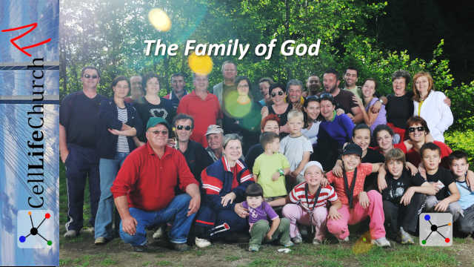
The Family of God
  - Finding Belonging in Christ
Every person longs to belong. We crave family, connection, and a place where we are truly known and loved. In Jesus, we find that place — the family of God. Discover how God welcomes us from spiritual isolation into belonging in Christ, giving us a name, a home, and an eternal inheritance.

Introduction – The Meaning of Family
When we think of family, we often picture parents, children, grandparents, aunts, uncles, and cousins. These are people connected by love, history, and shared life. Family means belonging. It is where we find acceptance, encouragement, and care, even when we fail.
In an ideal world, family members stand by one another through every season. They celebrate victories, support one another in hardship, and walk through life side by side. But not every earthly family is perfect. Some are broken. Others are distant. Many of us long for the kind of deep connection we were created for, a sense of home that lasts.
The good news is that God offers us that kind of family through Jesus Christ. Scripture tells us in John 1:12-13:

John 1:12-13
(12) Yet to all who did receive him, to those who believed in his name, he gave the right to become children of God— (13) children born not of natural descent, nor of human decision or a husband's will, but born of God.
Through faith in Jesus, we are invited into something greater than an earthly family. We are welcomed into the family of God, where love, forgiveness, and belonging in Christ redefine who we are and how we live.
In this teaching, we will explore three stages of spiritual belonging: orphaned, fostered, and adopted. We will learn that Jesus transforms us from outsiders to beloved sons and daughters in God’s household.

From Spiritual Orphans to Found Children
Every one of us begins life spiritually orphaned. Sin separates us from our heavenly Father, leaving us wandering, empty, and alone. We may fill our days with work, possessions, or relationships, but without God, there remains a deep ache, a longing for home.
Spiritual orphans live with a survival mindset. Life feels like “me against the world.” We fend for ourselves, trusting no one and hoping only to make it through another day. It is a lonely way to live.
But God sees every orphaned heart. Psalm 68:5–6 describes Him as “a father to the fatherless... God sets the lonely in families.” That is His heart, to bring His lost children home.
Sometimes, this begins with an invitation. Someone reaches out, offers a meal, extends kindness, or says, “Come to church with me.” It is in those moments that spiritual orphans glimpse what love and belonging look like. That invitation can be the first step toward coming home.
If you are feeling alone today, like no one truly understands or cares, know this: your heavenly Father is searching for you. He has prepared a place for you in His family. You do not have to wander any longer.

Living as Foster Children of Faith
When a spiritual orphan begins connecting with believers, attending church, joining a small group, or simply spending time around Christians, they begin to experience what life in God’s family is like. It is much like a foster child entering a loving home for the first time.
In a foster home, there is safety, warmth, and care. The child receives meals, rest, and affection. But there is still uncertainty, the lingering question, “Will I really stay?”
In the same way, when we start learning about Jesus and engaging with His people, we enjoy the blessings of God’s family, but we have not yet made it permanent. We are learning what grace feels like. We are exploring trust.
This is why the Church is so important. As the body of Christ, we are called to open our homes, hearts, and lives to those who are seeking belonging in Christ. Our love, patience, and hospitality help spiritual foster children see the Father’s heart.
We read in Romans 15:7,

Romans 15:7
(7) Accept one another, then, just as Christ accepted you, in order to bring praise to God.
Every time you show kindness to someone new, especially someone unsure about faith, you reflect the welcome of Jesus. You may be the bridge God uses to move a person from spiritual foster care to full adoption into His family.

Adopted into the Family of God
Adoption is one of the most powerful pictures of God’s love. It is a legal, permanent act that gives a new name, identity, and inheritance.
John 1:12 says that those who receive Jesus and believe in His name have the right to become children of God. That means you are no longer a stranger or a guest, you are family.
Ephesians 2:19–22 describes it this way:

Ephesians 2:19-22
(19) Consequently, you are no longer foreigners and strangers, but fellow citizens with God's people and also members of his household, (20) built on the foundation of the apostles and prophets, with Christ Jesus himself as the chief cornerstone. (21) In him the whole building is joined together and rises to become a holy temple in the Lord. (22) And in him you too are being built together to become a dwelling in which God lives by his Spirit.
Through faith, you are adopted into the household of God. You have a Father who loves you unconditionally, a Savior who calls you brother or sister, and countless spiritual siblings around the world who share your same family name, Christian.
Adoption also brings inheritance. Romans 8:17 says, “If we are children, then we are heirs—heirs of God and co-heirs with Christ.” Everything that belongs to Jesus, peace, joy, and eternal life, now belongs to you.
Of course, even in God’s family, we sometimes disagree or hurt one another. But like any loving parent, our Father helps us reconcile and grow. The Church is not perfect, but it is filled with imperfect people learning to love as Jesus loves.
To be part of the family of God is to live in grace and truth, together. It means forgiving one another, praying for one another, and standing strong together as His children.

Conclusion – Welcome Home
You were never meant to live life alone. God created you for connection with Him and with His people. Whether you have felt like a spiritual orphan, a foster child exploring faith, or a son or daughter who has wandered away, the Father’s arms are open wide.
He invites you to belong in Christ, to be part of His family where love is unconditional, mercy is abundant, and hope never runs out.
If you have never said “yes” to Jesus, you can do that right now. Simply pray, “Jesus, I believe in You. I ask for Your forgiveness and I give my life to You.” When you do, you are no longer a guest; you are adopted into the family of God.
And if you have already been adopted, live like it! Share the family love. Welcome others into the household of faith. Encourage the lonely and remind them there is a place where they truly belong, in Christ.

This Week
This week:
- Reflect: Take time this week to thank God for adopting you into His family. Read John 1:12–13 and Ephesians 2:19–22 each day.
- Reconnect: Reach out to someone who may be feeling spiritually alone and invite them into your faith community. A simple invitation can change a life. Maybe share this teaching or video with someone.
- Rejoice: Celebrate that you are not just part of the Church, you are part of the eternal family of God, joined together in Christ forever.

