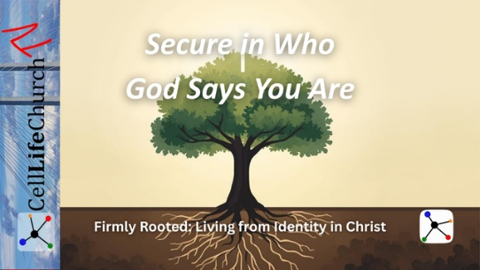
Secure in Who God Says You Are
  - Firmly Rooted: Living from Identity in Christ – Week 2

Introduction
Today we are continuing our series, Firmly Rooted: Living from Identity in Christ.
Last week we talked about being firmly rooted in Christ, and how deep spiritual roots give us strength, stability, and gratitude in every season of life. This week we are talking about something closely connected to that foundation.
We are talking about identity.
All around the world, people struggle with identity. Some people define themselves by success or failure. Some define themselves by their past, their struggles, their culture, or the expectations of others. Many people spend years trying to prove who they are, or trying to become someone they believe they must be in order to be accepted.
But God does not begin with labels. God begins with truth. God begins with identity.
Our faith does not only tell us what to believe. Our faith also tells us who we are. And when we understand who we are in Christ, we begin to live with confidence, peace, and security.

Scripture Reading
Let us read from Ephesians chapter 1:3-7.

Ephesians 1:3-7
(3) Praise be to the God and Father of our Lord Jesus Christ, who has blessed us in the heavenly realms with every spiritual blessing in Christ. (4) For he chose us in him before the creation of the world to be holy and blameless in his sight. In love (5) he predestined us for adoption to sonship through Jesus Christ, in accordance with his pleasure and will— (6) to the praise of his glorious grace, which he has freely given us in the One he loves. (7) In him we have redemption through his blood, the forgiveness of sins, in accordance with the riches of God's grace
These verses give us a powerful picture of who we are in Christ.

God Chose Us and Gave Us Identity in Christ
Paul tells us that God chose us in Christ before the creation of the world. This means our identity does not begin with our performance, our achievements, or our failures. Our identity begins with God.
Before we were born, God already knew us. God already loved us. God already had a purpose for our lives. Our worth does not come from what we do. Our worth comes from who we belong to.
Think about a child in a family. A child does not earn their place every day. They belong because they are part of the family. In the same way, God does not ask us to earn His acceptance. He invites us to live from the identity He has already given us in Christ.
Take a moment and reflect on this.
What have you allowed to define your identity? Your past? Your reputation? Your mistakes? Your achievements? The opinions of others?
God says, “Your identity begins in Me.”

God Redeemed Us and Removed Our Old Labels
Paul also says that in Christ we have redemption and forgiveness through His blood. This means our old labels no longer define us.
The world may have called us broken, unworthy, weak, or unacceptable. Our past may have declared us guilty or ashamed. But in Christ, those labels are not our identity.
God does not define us by our worst moments. God defines us by His grace. In Christ, we are forgiven. We are redeemed. We are restored.
Many people carry invisible burdens, like a heavy backpack filled with words such as “failure,” “not good enough,” or “unlovable.” But when we come to Christ, He lifts those burdens. Our identity is no longer shaped by shame. Our identity is shaped by grace.
Take a moment and ask yourself:
What false labels have I been carrying?
Which voices have shaped how I see myself?
Bring those to God and allow His truth to replace those lies.

Growing Through Community
If you feel comfortable, we invite you to share a truth from Scripture that strengthens your identity in Christ in the comments below. Your story may encourage someone else in our global church family.

God Adopted Us Into His Family and Gave Us Belonging
Paul says that God adopted us as His children through Jesus Christ. Adoption means we are not outsiders. We are not distant observers of God’s kingdom. We are welcomed into God’s family.
We belong.
We do not live for acceptance. We live from acceptance. We do not live in fear of rejection. We live in the assurance of God’s love.
Adoption means we are wanted, we are valued, and we are secure in God’s family.
Take a moment and let this truth speak to your heart:
You are not abandoned.
You are not forgotten.
You are not unnoticed.
You are a child of God.
Let that truth settle deeply in your heart and mind.

Conclusion
Our identity in Christ gives us peace, confidence, and purpose.
We are chosen.
We are redeemed.
We are adopted into God’s family.
We do not need to chase identity.
We do not need to prove identity.
We simply live from the identity God has already given us in Christ.
When we know who we are in Christ, we can walk in freedom, gratitude, and hope.

This Week
This week, we encourage you to:
- Read Ephesians chapter 1 slowly
- Write down three truths about your identity in Christ
- Pray and ask God to help you live from those truths each day
Let God’s truth define who you are.

Looking Ahead
Next week, we will talk about what it means to live as people who are adopted, not abandoned, and how belonging to God changes the way we face fear, hardship, and uncertainty.

For Leaders and Small Groups

Main Truth
Identity in Christ brings confidence, peace, and belonging.

Key Scripture
Ephesians 1:3–7

Discussion Questions
- What voices or influences most often shape how people see their identity?
- Which identity truth in Ephesians 1 speaks most deeply to you?
- What false labels has God helped you let go of?
- How does adoption into God’s family bring security and hope?

Suggested Practice
Invite group members to write one identity truth from Scripture and speak it in prayer each day this week.

