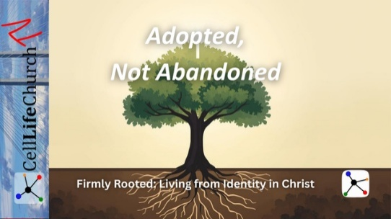
Adopted, Not Abandoned
  - Firmly Rooted: Living from Identity in Christ – Week 3
This teaching explores what it means to live as people who are adopted into God’s family and no longer abandoned or alone. When we understand our belonging in Christ, fear loses its power and confidence, hope, and trust begin to grow.

Introduction
Today we continue our series, Firmly Rooted: Living from Identity in Christ.
In Week 1, we talked about being firmly rooted in Christ and building our lives on a strong spiritual foundation. In Week 2, we talked about identity and learning to be secure in who God says we are. Today, we move one step deeper and talk about belonging.
Many people live with a deep fear of abandonment. Some have experienced rejection from family, friends, or authority figures. Others carry quiet fears of being unwanted, unseen, or alone. Even believers can struggle with these fears.
Scripture gives us a powerful truth:
In Christ, we are not abandoned.
In Christ, we are adopted.

Scripture Reading
Our Scripture today comes from Romans 8:14-17:

Romans 8:14-17
(14) For those who are led by the Spirit of God are the children of God. (15) The Spirit you received does not make you slaves, so that you live in fear again; rather, the Spirit you received brought about your adoption to sonship. And by Him we cry, ‘Abba, Father.’ (16) The Spirit Himself testifies with our spirit that we are God’s children. (17) Now if we are children, then we are heirs—heirs of God and co-heirs with Christ.”
These verses speak directly to fear, belonging, and identity.

God Does Not Lead Us by Fear
The Apostle Paul reminds us that believers are not led by fear, but by the Spirit of God. Fear tells us that we are alone, that we do not belong, and that we must protect ourselves. But God does not lead His children through fear.
For many believers, fear does not appear dramatic. It appears quietly. It sounds like thoughts such as, “What if I disappoint God?” or “What if I am not doing enough?” Some people believe God loves them, but they never feel at ease in His presence.
That kind of fear does not come from God.
God does not motivate His children through anxiety or threat. He leads us through love, patience, and relationship. He treats us like children who belong, not servants who might be dismissed.
Think about the difference between a visitor and a family member. A visitor feels careful and uncertain. A family member feels free and welcome. God invites us to live as family, not as visitors.
Reflection:
Where has fear shaped how you relate to God?
Do you live as someone who belongs, or as someone who feels guarded and uncertain?

God Adopted Us as His Children
Paul tells us that the Spirit we received brought about our adoption. Adoption is intentional. Adoption is permanent. Adoption is rooted in love.
When God adopted us, He did not bring us into His family reluctantly. He welcomed us with purpose and joy.
Many believers understand forgiveness, but still struggle with belonging. They believe God forgives them, but they continue to live as if they must earn their place. They live carefully, as though one mistake could change God’s mind.
This is the difference between living like a guest and living like a child.
A guest worries about saying the wrong thing.
A guest wonders if they are staying too long.
A guest feels pressure to behave perfectly.
A child belongs.
A child knows where they stand.
A child rests in the relationship.
God did not adopt us so we would live on probation. He adopted us so we could live in security.
Reflection:
Do you live as someone who knows they belong to God’s family, or as someone still trying to earn acceptance?

Share and Encourage Others
If you are comfortable, we invite you to share in the comments below.
What truth helps you remember that you belong to God’s family?
Your words may encourage someone who is struggling with fear, uncertainty, or loneliness.

God Gives Us Confidence and Hope Through Belonging
Paul continues by saying that if we are children, then we are heirs. This means we are not only accepted, but included in God’s promises.
Belonging gives us confidence.
Belonging gives us hope.
Belonging gives us strength to endure difficult seasons.
Life still brings hardship. Faith does not remove challenges. But belonging reminds us that we never face hardship alone.
For some people, this truth is difficult to trust. If you have experienced abandonment or broken relationships, the idea of belonging may feel uncertain. God understands that struggle.
He does not ask you to believe this truth instantly.
He invites you to learn it slowly.
He proves His faithfulness over time.
Even when feelings waver, God’s commitment does not. Belonging in Christ is not fragile. It is anchored in God’s promise.
Take this truth to heart:
You are not abandoned.
You are not forgotten.
You are not unseen.
You are a child of God.

This Week
This week, we encourage you to:
Read Romans 8:14–17 each day
Thank God for adopting you into His family
Ask God to replace fear with confidence and trust
Allow the truth of belonging to move from your mind into your heart.

Looking Ahead
Next week, we will conclude this series by talking about abiding in Christ and learning how staying connected to Him produces spiritual fruit in our lives.

For Leaders and Small Groups

Main Truth
Belonging in God’s family replaces fear with confidence and hope.

Key Scripture
Romans 8:14–17

Discussion Questions
- How does fear affect the way people relate to God?
- What does adoption into God’s family mean to you personally?
- What helps you remember that you belong to God?
- How does belonging change the way we face hardship?

Suggested Practice
Invite group members to thank God each day for adopting them into His family and to reflect on how that truth shapes their faith.

